**SonarQube Server Installation**

**Install Java (Java is the Pre-Requisite Software)**

**Hardware Requirements for SonarQube**  
The SonarQube server requires at least 2GB of RAM to run efficiently and 1GB of free RAM for the OS.

1.Connect to the server

2.Switch to root user sudo su –

3.Install the Java

sudo yum install java-11-amazon-corretto-devel -y

to check the java version

java –-version or java –version

4.switch to the opt

Cd /opt



5. **Download the SonarqQube Server software.**

cd /opt  
  
wget <https://binaries.sonarsource.com/Distribution/sonarqube/sonarqube-9.6.1.59531.zip>

yum install unzip -y

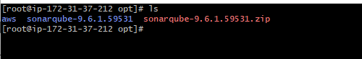

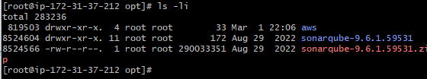

6.Rename the SonarQube with the name of sonar by using the command

mv sonarqube-9.6.1.59531 sonarqube

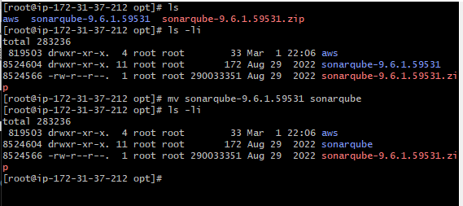

7.**As a good security practice, SonarQube Server is not advised to run sonar service as a root user, so create a new user called sonar user and grant sudo access to manage nexus services as follows.**

useradd sonar

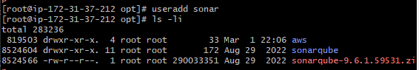

**8. Give the sudo access to sonar user by using the below command**   
 visudo



Then Cntrl+o, then hit the Enter and cntrl+x to exit from the scree.

9. **Change the owner and group permissions to /opt/sonarqube/ directory**

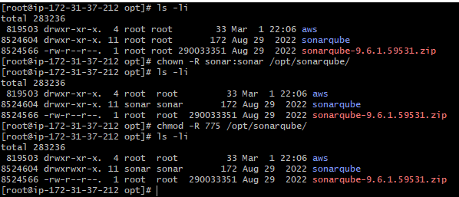

10. switch to sonar su – sonar

11.pwd🡪home/sonar

12.cd /opt/sonarqube->pwd 🡪/opt/sonarqube

13.cd bin-Linux.x86.64->sonar.sh

To start the sonar server : sh sonar.sh start

To check the status – sh sonar.sh status

Note :- By Default port Number is 9000